The Parts of a Typical Microscope
Click on the parts for more info!
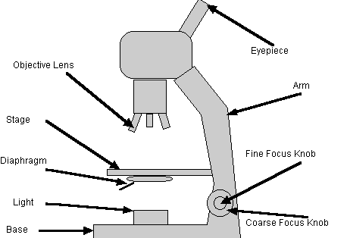
Microscope Parts Magnification General Procedures
Drawing Tips Making a Wet Mount Staining a Slide Final Note Top
How to figure out the Magnification:
 | Eyepiece | Objective Lens | Magnification
Low Power | 10 x | 10 x | 100 x
Green = GO! | Green = GO! | Green = GO! | Green = GO!
High Power | 10 x | 43 x | 430 x
Yellow = Caution | Yellow = Caution | Yellow = Caution | Yellow = Caution
Oil Lens | 10 x | 97 x | 970 x
Red = STOP! | Never Use This Lens! | or 100 x | or 1000 x
GENERAL PROCEDURES:
Microscope Parts Magnification General Procedures
Drawing Tips Making a Wet Mount Staining a Slide Final Note Top
1. Make sure all backpacks are out of the aisles before you get a microscope! Always carry the microscope with one hand on the Arm and one hand on the Base. Carry it close to your body.
2. Remove the cover, plug the microscope in, and place the excess cord on the table! If you let the excess cord dangle over the edge, your knee could get caught on it, and the next sound you hear will be a very expensive crash. I will bill you later!
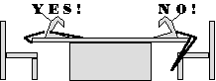
3. Always start and end with Low Power! The Green means GO! -- “Go ahead and put the slide on the stage.” “Go ahead and use the Coarse focus knob.” “Go ahead and remove the slide from the stage.” “Go ahead and put the microscope away.”
4. Place the slide on the microscope stage, with the specimen directly over the center of the glass circle on the stage (directly over the light). Then you have a 9 out of 10 chance of finding the specimen as soon as you look through the eyepiece!
NOTE: If you wear glasses, take them off; if you see only your eyelashes, move closer. Be sure to close, or cover your other eye!!
NOTE: If you see a dark line that goes part way accross the field of view, try turning the eyepiece. That dark line is a pointer that will be very valuable when you want to point out something to your lab partner, or your teacher!
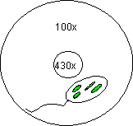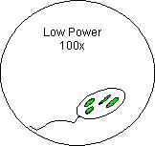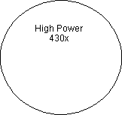
5. If, and ONLY if, you are on LOW POWER, lower the objective lens to the lowest point, then focus using first the coarse knob, then the fine focus knob. The specimen will be in focus when the LOW POWER objective is close to the lowest point, so start there and focus by slowly raising the lens. If you can’t get it at all into focus using the coarse knob, then switch to the fine focus knob.
6. Adjust the Diaphragm as you look through the Eyepiece, and you will see that MORE detail is visible when you allow in LESS light! Too much light will give the specimen a washed-out appearance. TRY IT OUT!!
7. Once you have found the specimen on Low Power (100x), unless specifically asked to draw it on low power, center the specimen in your field of view, then, without changing the focus knobs, switch it to High Power. If you don’t center the specimen you will lose it when you switch to High Power (Yellow). [See Above]
8. Once you have it on High Power remember that you only use the fine focus knob! The Yellow means CAUTION! -- “Caution, use only the fine focus knob.” “Caution, do not remove the slide when it is on High Power.” -- The High Power Objective (430x) is very close to the slide. Use of the coarse focus knob will scratch the lens, and crack the slide. More expensive sounds . . .
9. NEVER USE THE RED LENS. The Red Means STOP!! -- “Stop! Don’t use that lens!” -- It is an oil immersion lens. Without the oil to lubricate the lens, you will destroy it! More expensive sounds . . . Also, the oil is needed to help gather enough light to actually see through the lens!
10.
Tips On Making Good Drawings:
Microscope Parts Magnification General Procedures
Drawing Tips Making a Wet Mount Staining a Slide Final Note Top
1. Don’t even think of starting your drawing unless you have a PENCIL! Drawings in PEN are UNACCEPTABLE! This is for two reasons:
(a) You can erase pencil!
(b) You can shade in areas more easily in pencil.
2. Each Drawing must be 1/2 page in size, and must include clear, proper labels! In the upper left hand corner of each circle include the specimen name as written on the slide label. In the upper right hand corner, include the magnification (100x or 430x).
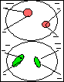
3. Labels should start on the outside of the circle. The circle indicates the field of view as seen through the eyepiece. All arrows should end with the point touching the object to be labeled!
4. Animal cells should always include at least the following five labels: Cell membrane, Nuclear membrane, Nucleus, Chromatin, Cytoplasm.
5. Plant Cells should always include at least the following seven labels: Cell membrane, Cell wall, Nuclear membrane, Nucleus, Chromatin, Cytoplasm, Chloroplast (this last does not exist in certain plant cells).
6. Remember: This class is about Connections! I don’t want you to Look at the cells; I want you to SEE them! In order to do that, you MUST:
Apply your knowledge of
cell structure to your drawings!
An unlabeled drawing is nothing more than
scratches on a piece of paper!
Check out the Tutorial on
LOOKING VS SEEING!
How To Make A Wet Mount:
Microscope Parts Magnification General Procedures
Drawing Tips Making a Wet Mount Staining a Slide Final Note Top
1. Gather a thin slice/piece of whatever your specimen is. If your specimen is too thick, then the coverslip will wobble on top of the sample like a see-saw:
2. Place ONE drop of water directly over the specimen. If you put too much water over the specimen, then the coverslip will float on top of the water, making it harder to draw the specimens as they float past the field of view!
3. Place the coverslip at a 45 degree angle (approximately), with one edge touching the water drop, and let go.

How To Stain a Slide:
Microscope Parts Magnification General Procedures
Drawing Tips Making a Wet Mount Staining a Slide Final Note Top
1. Place one drop of Methylene Blue stain on one edge of the coverslip, and the flat edge of a piece of paper towel on the other edge of the coverslip. The paper towel will draw the water out from under the coverslip, and the cohesion of the water (due to those perennial favorites - Hydrogen Bonds) will draw the stain under the coverslip.
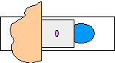
2. As soon as the stain has covered the area containing the specimen you are finished. The stain does not need to be under the entire coverslip. If the stain does not cover the area needed, get a new piece of paper towel and add more stain until it does.
3. Be sure to wipe off the excess stain with a paper towel, so you don’t end up staining the objective lenses.
4. You are now ready to place the slide on the microscope stage. Be sure to follow all the instructions on the previous pages as to how to use the microscope.
5. When you have completed your drawings, be sure to wash and dry both the slide and the coverslip and return them to the correct places!
6. All slides must be put away in the proper trays! Students will not leave until all materials have been put way properly. You are a team!

Final Note:
NOTE: These procedures will remain the same,
regardless of the type of stain,
or the addition of a hypertonic/hypotonic solution to your specimen.
REMEMBER: Be careful with the equipment,
and be sure to leave the lab
in the same condition it was in when you arrived.

